CS 519 Cloud Computing Overview

**VL03: Going Global with AWS Global Infrastructure**

School of Technology and Computing

## **Instructions**

## For this activity you will study this case:

<https://press.aboutamazon.com/news-releases/news-release-details/twitter-selects-aws-strategic-provider-serve-timelines>

**Countries with the most Twitter users 2020**

**Source:** <https://www.statista.com/statistics/242606/number-of-active-twitter-users-in-selected-countries/>

Published by J. Clement, Oct 29, 2020

Social network Twitter is particularly popular in the United States, where as of October 2020, the microblogging service had audience reach of 68.7 million users. Japan and the India were ranked second and third with 51.9 and 18.9 million users respectively. Global Twitter usage As of the fourth quarter of 2019, Twitter had 152 million monetizable daily active users worldwide. The most-followed Twitter accounts include celebrities such as Katy Perry, Justin Bieber and former U.S. president Barack Obama.

**Leading countries based on number of Twitter users as of October 2020(in millions)**

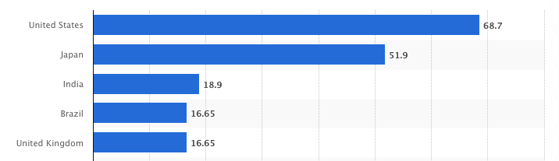

Given the top five leading countries in the above bar graph, look for the closest AWS Regions and Availability Zones for the five countries.

**Resources to check the list of RAZs:**

<https://infrastructure.aws/>

<https://aws.amazon.com/about-aws/global-infrastructure/regions_az/>

There are 7 regions in North America. 1 in Canada and 6 in United States. They all have at least 3 availability zones. For united states, there should be at least two regions, one in the east, one in the west.

There are 9 regions in asia pacific. Looks like there are two regions in japan. Tokyo and osaka. Since japan is a much smaller country, we don’t have to use regions but depending on the performance tests, we could use both regions. Osaka has 1 availability zone so we shouldn’t use that alone. Tokyo ahs 4 availability zones.

There is only one region in india which is mumbai. But it is centrally located in india. It has 3 availability zones.

South america has only one region with three availability zones.

United kingdom has one region in london with 3 availability zones.